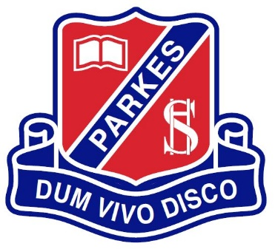
Parkes High School
Year 10 into 11 Subject
Selection Interview 2021

Name: _____________________________ Date: ______________________
 | Subject Choice | Category  A OR B | Board developed OR Board endorsed  OR Content Endorsed | ATAR  OR  NON ATAR | UNIT Value
1 | English  Extension with Advanced  Advanced  General  Studies
2
3
4
5
6
 |  |  |  |  | Add the total of your units here
Back up 1
Back up 2

University Course: _____________________________________________________________
Prerequisites: ___________________________________________________________

